**Week 8**

**5.1** ALL perspective views are characterized by diminution of size.  When objects moved farther from the viewer, their images becomes smaller.  How does the classical perspective view work?

The classical perspective views are usually known as one, two and three-point perspective. The differences among the three cases are based on how many of the three principal directions in the object are parallel to the projection plane. For example, for three point perspective, parallel lines in each of the three principal directions converges to a finite vanishing point. If you want to place something in the middle between two objects draw the diagonals between the objects. The further away the objects are, the smaller they appear. Symmetric Frustum

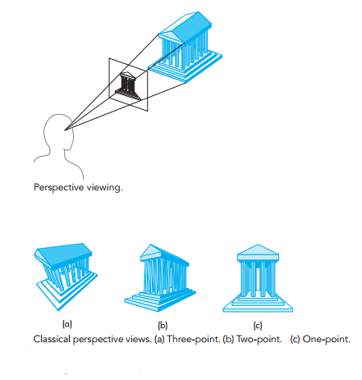

**5.7** What is a shadow polygon?

A shadow polygon is the projection of a polygon on a surface in relation to a light source.

**5.21** Stereo images are produced by creating two images with the viewer in two slightly different positions. Consider a viewer who is at the origin but whose eyes are separated by dx units.  What are the appropriate viewing specifications to create the two images?

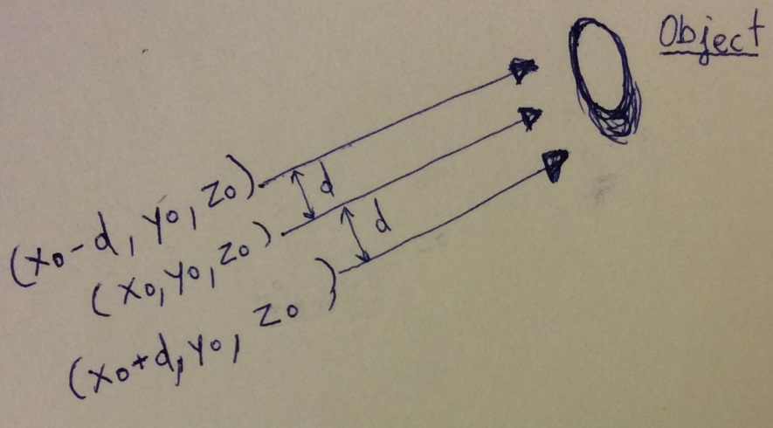

As we can see the only difference is the distance in the Axis x. Therefore, the coordinates of the Axis y and z are the same for both positions. However, the coordinate for Axis x we add the distance dx for the first image and we subtract the distance dx for the second image.

**5.25** What is the use of Projection Normalization?

Projection Normalization is used to convert arbitrary sized clipping coordinates to any projection to be used as part of the pipeline. It converts perspective view volume to orthogonal view volume to further standardize camera representation.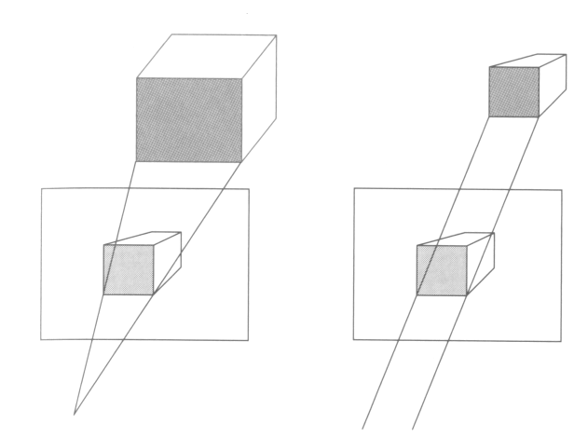

Normalization also allows for a single pipeline for both perspective and orthogonal viewing. It is possible to see in the picture.